Balch Springs Community Emergency Response Team

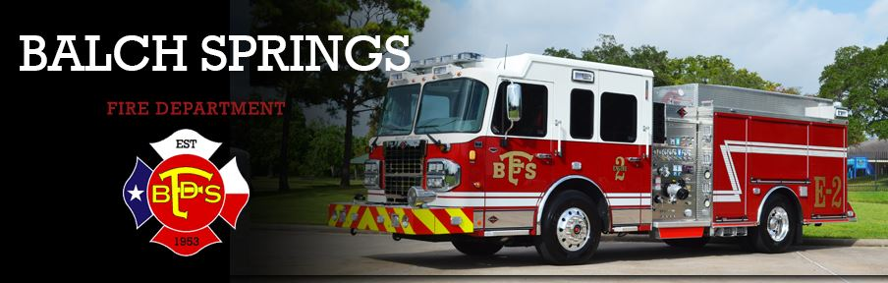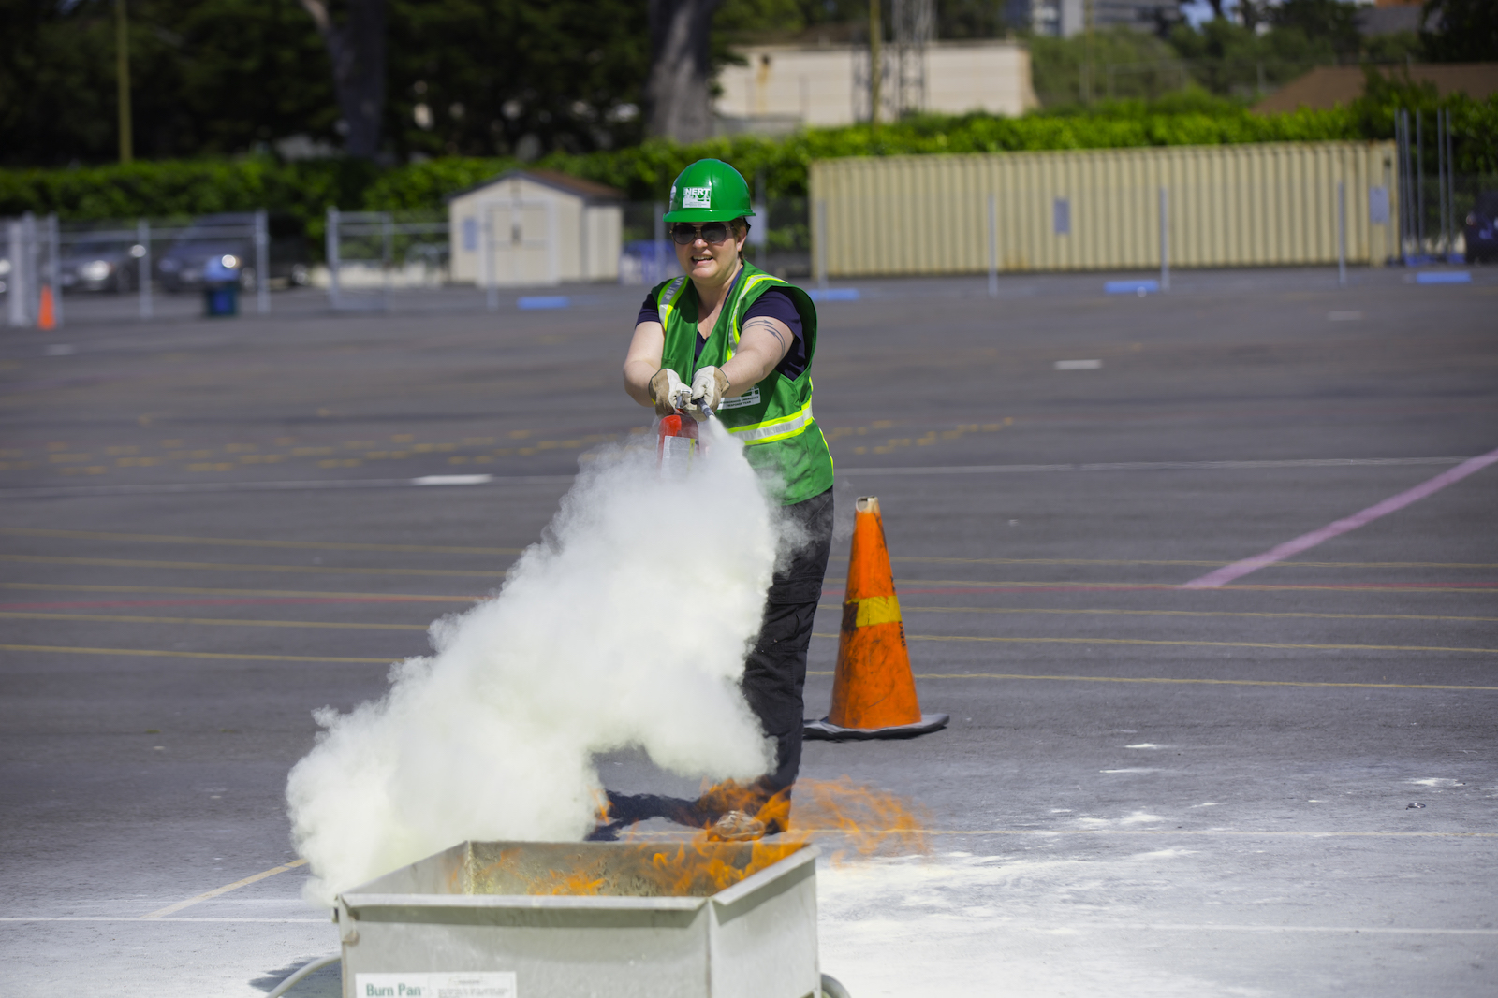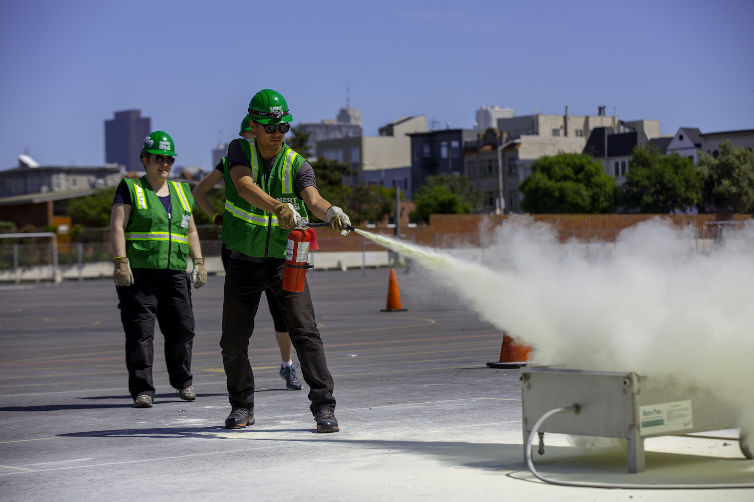
The Community Emergency Response Team (CERT) program educates volunteers about disaster preparedness for the hazards that may impact their area and trains them in basic disaster response skills, such as fire safety, light search and rescue, team organization, and disaster medical operations. CERT offers a consistent, nationwide approach to volunteer training and organization that professional responders can rely on during disaster situations, allowing them to focus on more complex tasks.
For more information, please contact Fire Chief Eric J. Neal of Balch Springs Fire Department.
Email: eneal@cityofbalchsprings.com
Phone: 972-557-6040
Location: 12500 Elam Rd. Balch Springs, TX 75180
