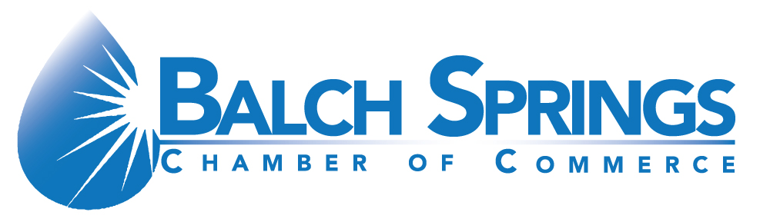 

Balch Springs Chamber

*9th Annual Celebrity Golf Classic*

Mesquite Municipal Golf Course

825 Interstate 30

Mesquite TX, 75150

**Friday, October 16, 2020 – Tee off Time: 8:00am**

**Check-In and Breakfast at 7:00am**



***Partial Proceeds to Benefit Texas Wounded Warrior Foundation***

**Register online at: balchspringschamber.org**

**$125.00/PERSON ENTRY FEE**

**$500.00/FOURSOME**

**Business/Contact Name ____________________________________________**

**Phone/Email_____________________________________________________**

**TEAM INFORMATION**

**Player Name Handicap**

**1__________________________________________________ ____________________________**

**2__________________________________________________ ____________________________**

**3__________________________________________________ ____________________________**

**4__________________________________________________ ____________________________**

**NAME: ____________________________________________________________________**

**COMPANY: ________________________________________________________________**

**ADDRESS: _________________________________________________________________**

**PHONE: ___________________________________________________________________**

**E-MAIL: ___________________________________________________________________**

**SPONSORSHIP LEVEL: ___________________CHECK NUMBER: ________________**

**For questions contact: The Chamber @972-557-0988 / 903-319-6668 (Best Contact Number)**

**or Terri Shatter Committee Chair @972-998-4682**

***9th Annual Celebrity Golf Classic Sponsorship Opportunities***

* **Title Sponsor $10,000 (1) Available**

This sponsorship level includes eight player entries, two signs with company logo displayed on the putting green. Sponsorship also comes with featured mention (including logo) in all publicity and on the main tournament banner, the ability to address the golfers at the after-event awards ceremony luncheon, eight special Title Sponsor golf shirts. Display of company banner (supplied by you). Banner Ad on tournament and chamber websites. **We will name the Golf Tournament after your company. Opportunity to provide gift item to Tournament participates. Interview with DFW Television station. Exclusive Video Promotion for Event.**

* **Presenting Sponsor $5,000 (1) Available**

This level of sponsorship will receive eight player entries, sign with company logo to be displayed on **#1-hole tee box**.  Name and logo on main tournament banner. Display of company banner (supplied by you). Banner Ad on chamber website.

* **Golf Cart Sponsor $2,500 (2) Available**

This level of sponsorship includes four player entries, signage on all player golf carts. Name and logo on main tournament banner. Banner Ad on chamber website.

* **Gold Sponsor $1,000 (12) Available**

Gold sponsors will receive four player entries, sign to be displayed on a hole tee box. Name and logo on main tournament banner. Banner Ad on chamber website.

* **Premium Hole Sponsor $300 (18) Available**

Sponsor Sign on Tee Box **PLUS** table, chairs, 10 x10 tent, promotional items, business card sign up and player gifts all supplied by you.

* **Hole Sponsor $175 (36)**

Sign with your company name will be displayed on a hole tee box.

* **Photography (1) /Beverage Sponsors (2): (In Kind)**

Special signage and recognition at awards ceremony luncheon.

* **Player Gifts (In Kind) suggestions but not limited to: golf shirts, sunglasses, trunk organizers, coolers, hats, or sleeve of golf balls**