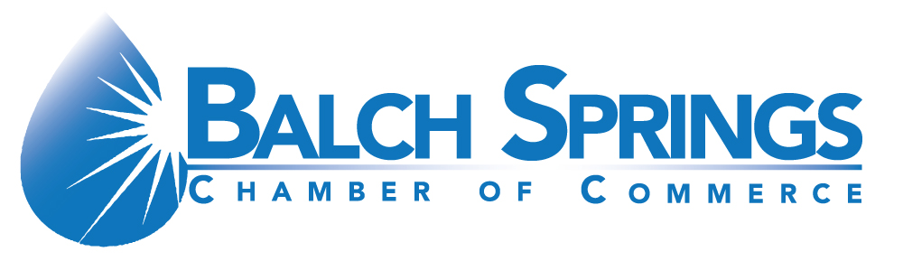 

Balch Springs Chamber

October Quarterly Luncheon!!

*“Celebrating Women in Leadership and Breast Cancer Awareness”*

Balch Springs Civic Center

12400 Elam Road

Balch Springs, TX 75180

**Thursday, October 17, 2019**

**11:00am – 1:00pm**

**Register online at: balchspringschamber.org**

**NAME: ____________________________________________________________________**

**COMPANY: ________________________________________________________________**

**ADDRESS: _________________________________________________________________**

**PHONE: ___________________________________________________________________**

**E-MAIL: ___________________________________________________________________**

**SPONSORSHIP LEVEL: ___________________CHECK NUMBER: ________________**

**For questions contact: The Chamber @ 972-557-0988 or ceo@balchspringschamber.org**

* **Presenting Sponsor $2,500 (1) Available**

Benefits include: Special priority seating for **eight** people (one table of eight). Company logo displayed on the Chamber website. Sponsorship also comes with featured mention (including logo) in all publicity. **One-year Chamber Membership** and the ability to address the attendees at the luncheon.

* **Platinum Sponsor $1,500**

Benefits include: Special priority seating for **six** people. Company logo displayed on the Chamber website. Sponsorship also comes with featured mention (including logo) in all publicity.

* **Gold Sponsor $1,000**

Benefits include: Special seating for **four** people. Company logo displayed on the Chamber website. Sponsorship also comes with featured mention (including logo) in all publicity.

* **Bronze Sponsor $500**

Benefits include: Special seating for **two** people. Company logo displayed on the Chamber website. Sponsorship also comes with featured mention (including logo) in all publicity.

* **Business Sponsor $250**

Benefits include: Company logo displayed on the Chamber website. Special recognition at the Chamber Luncheon.

* **Ticket $20 each**

I an unable to be a sponsor but would like to purchase tickets to the luncheon.

Individual Tickets $20 each = _________________

[](https://www.google.com/url?sa=i&rct=j&q=&esrc=s&source=images&cd=&ved=2ahUKEwiZ9-OX1M7kAhU2CTQIHSRpDHgQjRx6BAgBEAQ&url=http%3A%2F%2Fwww.nationaldiversitycouncil.org%2Fthe-illinois-divertsity-council-hosts-inaugural-chicago-women-in-leadership-symposium%2F&psig=AOvVaw35dhBn9MHkMNFdRy5Aid-d&ust=1568493456963113)